A Python Synopsis on

**YOUTUBE VIDEO DOWNLOADER**

Submitted to Manipal University Jaipur

Towards the partial fulfilment for the Award of the Degree of

**BACHELOR OF TECHNOLOGY**

In Computers Science and Engineering

2023-2027

By

Abhyudit Singh  
23FE10CSE00790



Under the guidance of

**Mr. Jay Shankar Sharma**

______________________________   
Signature of Teacher  
 Department of Computer Science and Engineering

School of Computer Science and Engineering

Manipal University Jaipur

Jaipur, Rajasthan

**Introduction**

The YouTube Video Downloader is a Python-based desktop application designed to simplify the process of downloading YouTube videos. The project employs Python's tkinter library to create a user-friendly graphical interface, while the yt-dlp tool is integrated for efficient video downloading. Users can paste a YouTube video link, select a download location, and download videos in various formats with ease. This project bridges the gap between the technical aspects of video downloading and the average user's needs, making it both accessible and practical.

**Journey and Learnings**

Developing this project has been a rewarding experience that enhanced my understanding of Python programming and GUI development. Here are the highlights of my journey:

* **Problem-Solving**:  
  Breaking down the requirements into components, such as link validation, folder selection, and download execution.
* **GUI Development**:  
  Designing a functional and visually appealing interface using tkinter.
* **Command Integration**:  
  Learning how to run external commands (yt-dlp) using the subprocess library in Python.
* **Error Handling**:  
  Managing user input errors and system-level issues to provide a smooth experience.

This project has not only improved my coding skills but also taught me how to integrate third-party tools effectively in Python applications.

**Software Used**

* **Python**: Core programming language used for the project.
* **tkinter**: Library used to design the graphical user interface.
* **yt-dlp**: Command-line tool for downloading YouTube videos.
* **Text Editor/IDE**: VS Code for writing and debugging the code.
* **Operating System**: Works on any OS supporting Python (Windows/Linux/Mac).

**Backend and User Interface (UI)**

* **Backend**:
  + Python's subprocess module is used to execute the yt-dlp command for downloading videos.
  + Logic for handling input validation and error scenarios ensures robust performance.

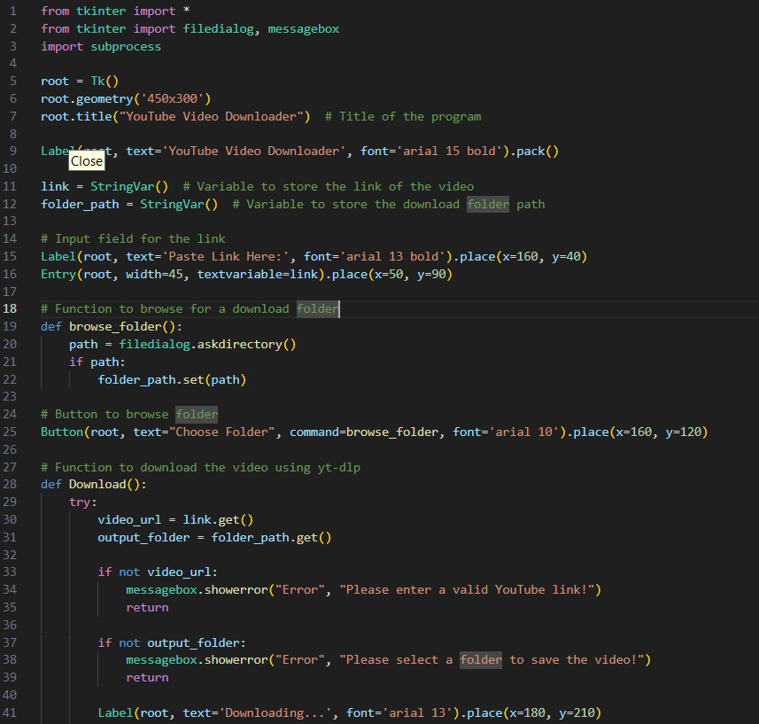

* **Frontend (UI)**:
  + Built with tkinter, featuring:
    - **Input Fields**: For video links.
    - **Buttons**: To select folders and start downloads.
    - **Messages**: To guide users through the process.

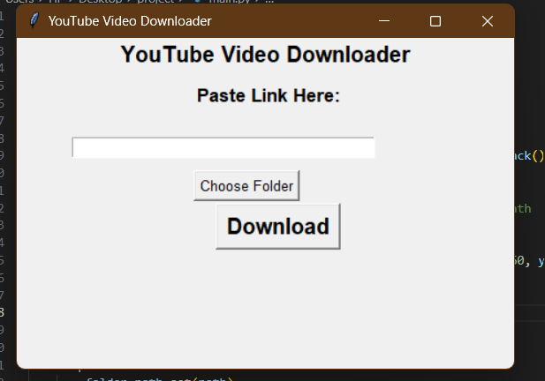

**Key Features**

1. **User-Friendly Interface**:  
   A clean and straightforward GUI built with tkinter.
2. **Folder Selection**:  
   Users can choose where to save the downloaded videos.
3. **Error Handling**:  
   Displays appropriate error messages for invalid links or missing folders.
4. **Seamless Integration**:  
   Combines Python with the powerful yt-dlp tool for downloading videos in the desired format.
5. **Cross-Platform**:  
   Compatible with Windows, macOS, and Linux.

**Conclusion**

The YouTube Video Downloader is a practical and efficient tool for managing video downloads. By combining a user-friendly interface with a robust backend, this project demonstrates the power of Python in simplifying everyday tasks. Throughout the development process, I have gained valuable insights into GUI design, system integration, and error handling, equipping me with skills to tackle more complex applications in the future.

Repositorylink : <https://github.com/A-b-hi/pythonlab-abhyudit.singh/tree/main/mini-project>